Life After Stroke: Rehabilitation and Recovery Process-H1
Author – Dr. Vishal Rokade, Consultant, Neuro Surgeon
Priority | Search Volume | Keyword Intent | ASV
P1 | how to recover from stroke quickly | informational | 1000
P1 | brain stroke recovery | informational | 1000
P2 | after brain stroke symptoms | informational | 720
P1 | recovery after stroke | informational | 720
P2 | signs of recovery from stroke | informational | 390
P2 | stroke recovery time | informational | 320
P2 | stroke side effects | informational | 170
P1 | stroke patient recovery | informational | 140
P2 | after stroke symptoms | informational | 140
P2 | treatment after stroke | informational | 140
P2 | Neurology Hospital in Pune | Business | 260

Title- Quick Stroke Recovery: Tips, Symptoms & Post-Stroke Care
Description- Explore effective ways to recover quickly from a stroke, understand after-stroke symptoms, and improve brain stroke recovery with helpful strategies.
Slug- /what-happen-after-stroke-treatment
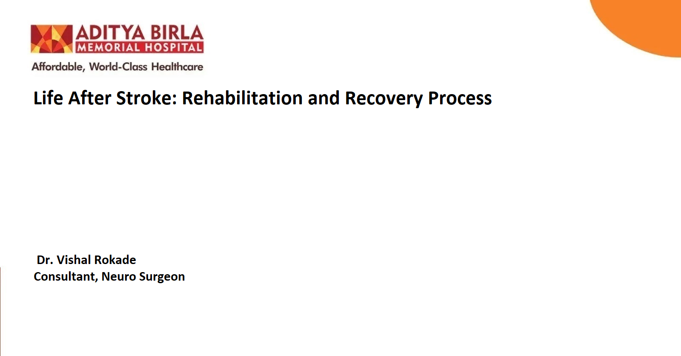
Recovering from a stroke is a journey that requires time, effort, and a tailored rehabilitation plan. While stroke recovery time varies for each person, factors like the size of the brain injury, its location, and the quality of treatment received all play significant roles. Rehabilitation involves working with specialists to improve mobility, communication, and everyday functions. Lifestyle changes, medications, and therapy can prevent another stroke. With the right care and persistence, many stroke survivors regain a fulfilling quality of life.

Stroke Overview-H2
A stroke occurs when blood flow to a part of the brain is interrupted, depriving it of oxygen and nutrients. This can lead to brain cell death, causing physical, cognitive, and emotional challenges. The severity and impact of a stroke depend on the size and location of the brain injury. Stroke is also the leading cause of adult disability globally, making recovery and rehabilitation essential for improving quality of life.
All this information will give you an idea of the severity of a stroke. When your body has suffered something so severe, the impact can be severe even after treatment.

What Happens After Stroke Treatment?-H2
Recovery after a stroke begins almost immediately after initial treatment, often within 1–2 days. This early intervention aims to help patients transition smoothly from hospital care to home and reduce the risk of another stroke.
- Stroke Recovery Time-H3
Recovery varies from person to person. For some, it may take weeks, while others may need months or years. Some individuals regain full functionality, while others may face lifelong disabilities.
- Signs of Recovery from Stroke-H3
The journey of brain stroke recovery is marked by gradual improvements, such as regaining strength, improved mobility, or the ability to perform daily tasks independently.
- After Stroke Symptoms-H3
Common after stroke symptoms include difficulty walking, muscle weakness, memory issues, trouble speaking, and emotional changes. These symptoms may improve with time and rehabilitation.
- Stroke Side Effects-H3
Post-stroke side effects include paralysis, difficulty swallowing, bladder issues, and cognitive challenges. Addressing these side effects early with medical guidance is vital for effective recovery.

Rehabilitation-H2
Rehabilitation is the cornerstone of recovery. Its goal is to help stroke survivors regain independence and improve their quality of life. A personalized rehabilitation plan often includes a combination of therapies:
- Speech Therapy-H3
Many stroke survivors struggle with communication or swallowing. Speech therapists can help patients relearn language skills, manage memory issues, and improve swallowing ability.
- Physical Therapy-H3
Physical therapy addresses muscle weakness, paralysis, and mobility issues. Therapists work with patients to rebuild strength, balance, and coordination.
- Occupational Therapy-H3
Occupational therapy helps individuals relearn daily tasks like eating, dressing, and bathing. Therapists also provide adaptive tools to support independence.
- Managing Other Symptoms-H2
- Bladder and Bowel Problems: A stroke can disrupt bladder and bowel control. Specialists provide medications and exercises to manage these issues.
- Swallowing and Eating Difficulties: Speech therapists may recommend changes in diet, such as chopping food or using thickened liquids to prevent choking.
Stroke patient recovery is most effective when therapists, caregivers, and healthcare providers work together to address each individual's needs.

Prevent Another Event-H2
After experiencing a stroke, individuals face an increased risk of recurrence. Preventive measures are critical and may include:
- Lifestyle Changes-H3
Adopting a healthier lifestyle by quitting smoking, eating a balanced diet, exercising, and managing stress can significantly reduce the chances of another stroke.
- Medications-H3
Blood thinners, cholesterol-lowering drugs, and medications to manage high blood pressure are often prescribed to prevent future strokes.
- Surgical Interventions-H3
In some cases, surgery may be necessary.
- Carotid Endarterectomy: Removes plaque buildup from the carotid arteries in the neck.
- Heart Surgery: Conditions like atrial fibrillation or patent foramen ovale may require surgical treatment to reduce stroke risk.
Recovering from a stroke quickly includes not only rehabilitation but also addressing the root causes of the stroke.

Speak with a Doctor-H2
Seeking professional medical advice is essential for stroke survivors. Regular follow-ups ensure that the recovery plan is on track, and any new or worsening symptoms are addressed promptly.
If you are in Pune, you can visit Aditya Birla Hospital in Pimpri-Chinchwad, a renowned neurology hospital in Pune. Our expert team offers specialized care and tailored treatment plans.

Conclusion-H2
Stroke recovery is a journey that varies for each individual. Through timely rehabilitation, medical intervention, and lifestyle changes, stroke survivors can regain independence and reduce the risk of recurrence. While challenges exist, persistence and the right support system can lead to meaningful recovery and an improved quality of life.

FAQs-H2
Can I live a long life after a stroke?-H3
Yes, many people live long and fulfilling lives after a stroke. Recovery depends on factors such as stroke severity, overall health, and adherence to rehabilitation and lifestyle changes.
Can people go back to normal after a stroke?-H3
Some individuals recover fully and return to their pre-stroke routine. For others, recovery may involve adapting to changes or coping with permanent disabilities.
Can stroke be cured permanently?-H3
While some individuals experience a full recovery, others may have lasting impairments. Effective management of underlying causes and ongoing rehabilitation play a key role in recovery.
References:-
CDC. (2024, May 20). Treatment and intervention for. Stroke. https://www.cdc.gov/stroke/treatment/index.html
Recovery. (n.d.). NHLBI, NIH. Retrieved November 25, 2024, from https://www.nhlbi.nih.gov/health/stroke/recovery
Recovery. (n.d.-b). National Institute of Neurological Disorders and Stroke. Retrieved November 25, 2024, from https://www.ninds.nih.gov/health-information/stroke/recovery
(N.d.). Nih.gov. Retrieved November 25, 2024, from https://pmc.ncbi.nlm.nih.gov/articles/PMC3962998/#

